8th grade Review Test Feb 1

Part I find the x and y Intercepts

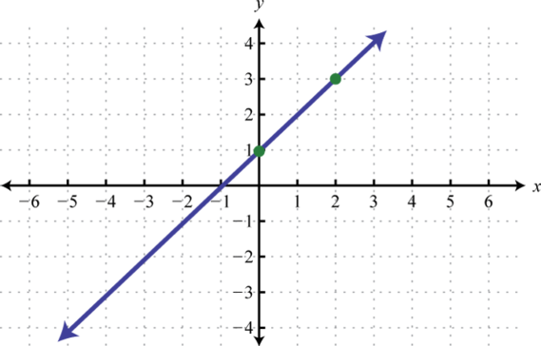

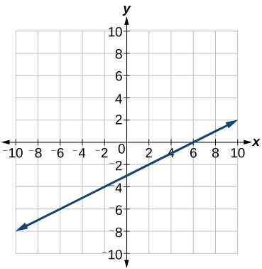

Part III find the x and y intercepts from the given equations

- $3x-7y=21$

- $5x-2y=10$

- $y=-x=4$
Part IV Use the slope formula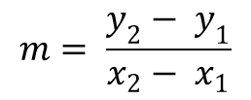to solve each exercise

- (2,5) , (8,1)

- (3,6) and ( 6,9)

Parts V use the slope formula to find the slope and graph each equation.

- $4x-2y=16$

- $8x+2y=96$
VI Tell whether each equation reprersents a direct variation if so identify the constant of variation

- $y=3x$

- $3x+y=8$

- $-4x+3y=0$

Part VII Tell whether each relationship is a direxct variation

x | 2 | 4 | 6
y | 6 | 12 | 18

x | 1 | 3 | 7
y | -2 | 0 | 4

- The value of y varies directly with x and y=3 when x = 9. Find y when x = 21

P)art VIII Write the equation that describes each line in slope-intercept form

- Slope = $\frac{1}{4}$; y-intercept = 4

- Slope = -9; y-intercept = $-\frac{5}{4}$

- Slope =2; (3,4) is on the line

Part IX Write each equation in slope-intercept form. Then graph the line described by the equation.

- $y=3x-1$

- $2y+3x=6$

Part V Write an equation in point-slope form for the line with the given slope that contains the given point

- Slope = $\frac{1}{6}$; (5,1)

- Slope =-4; (0,3)

- Slope = 1;(-1,-4)

