7th Review Test Date August 31,2018

Part I Evaluate the expression when X = 8 show all steps

- $x+5$

- $23-x$

- $\frac{x}{4}$

- 20x

Part II Evaluate the expression when a = 3, b=4 and c = 20 show all steps (2pts each)
- $a+b$
- $ca$
- $ca$
- $\frac{c}{c}$
Part III Solve the Story problem. (3 pts each)

1. Gift Card application you can evaluate the expression 200-d to find the amount you have left on a $200 gift card after you have spent d dollars. Find the amount you have left after you have spent $16

Part IV Write the power in words and as a repeated multiplication. Then evaluate each power (2pts)

  - $8^{3}$
  - $2^{7}$
  - ${0.2}^{3}$
  - ${07}^{3}$

Part V Evaluate each expression using order of operations
- $800-7(2+3)²$
- $20x5+7x3$
- $\frac{5+4}{3}$-
- $17-(3^{2}-2)$
- $48÷6+2$
Part VI Graph the integers on a number line. Then write the Integers in order
  - 4,0,-3,7-6
  - 2,-3,4,6,-5

Part VII State the absolute value and opposite of the number.
- 14
- -8
- 4
- -100

Part VII adds or subtract the following integers (2pts each)

- $-2+7=$
- $-3+4=$
- $-7+-5=$
- $-9+2=$
Part IX Subtract Each Integer

- $3-\left(-5\right)=$

- $2-4=$

- $-8-\left(-4\right)=$

- $-5-4=$

Part X Multiply and Divide the following Integers
- $-5x15=$
- $-7x12=$
- $\frac{-25}{4}$=
- $-2 x-525=$
- $\frac{-16}{-3}$=
- $\frac{-32}{4}$=

Part XI Plot the point in a coordinate plane. Describe the location of the point.
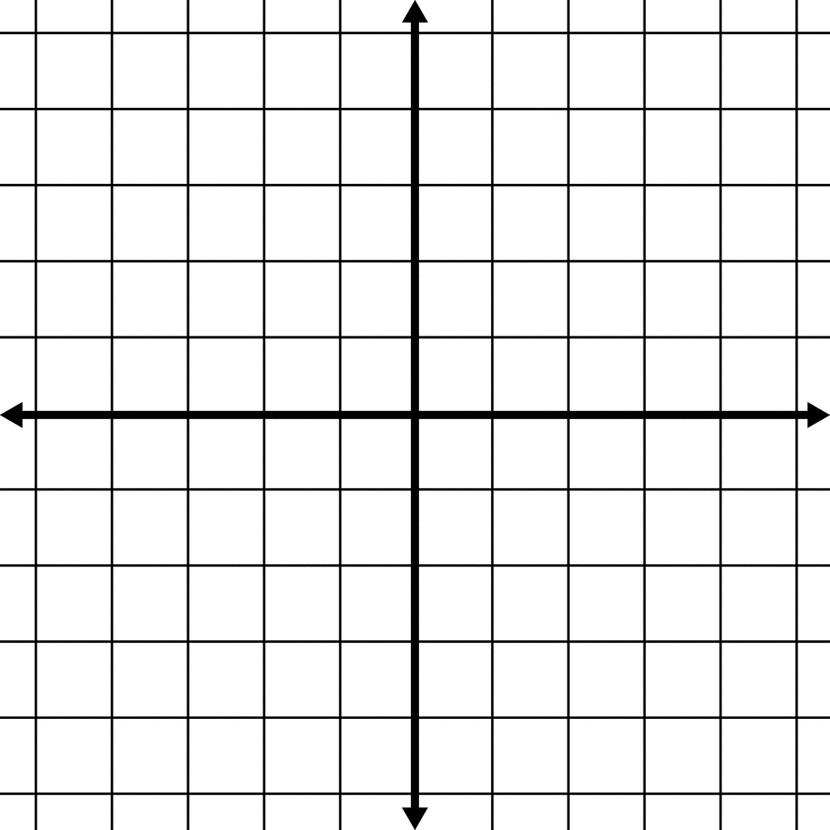
.
1. A(5,5)
2. B(-1,0)
3. C(-4,-1)
4. D( 6,-5)
5. E. (2,-4)

