Review Test September 27, 2018 7th Grade
Part I Plot the point in a coordinate plane. Describe the location of the point
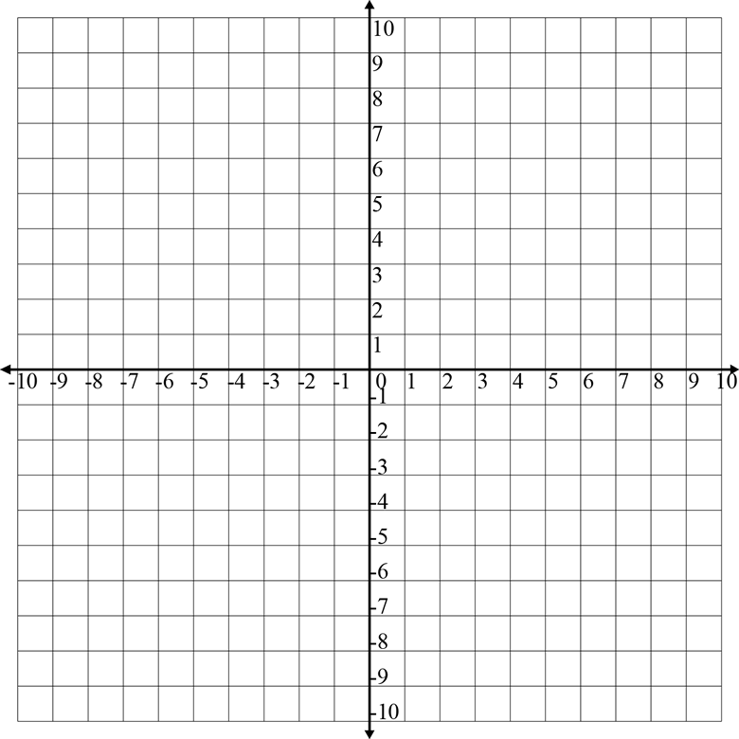
1. A(-2,5)
2. B(-4,0)
3. C (2,-1)
4. D( 7, 7)
5. E. -10,-4)

Part II Identify each point on the coordinate plane (2pts each)
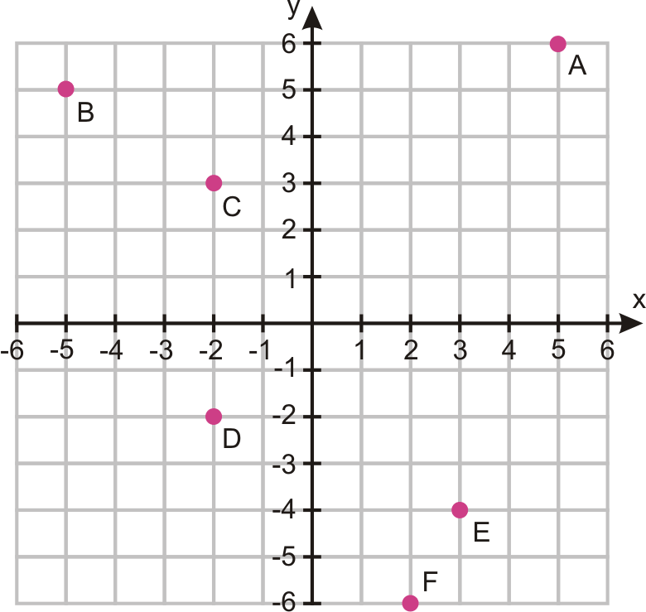

1.
2.
3.
4.
5.
6.

III Identify which property of real number applies in each example (2pts each)

- $3+4=4+3$

- $\left(d+4e\right)+7f=d+(4e+7f)$

- . $3x+1=3x$

d. $\left(4\right)\left(-7\right)=\left(-7\right)(4)$
Part IV Use the distributive property to write an equivalent variable expression (\

- $9(12+k)$

- $\left(y+6\right)(-3)$

- $8(2z+6)$

4.

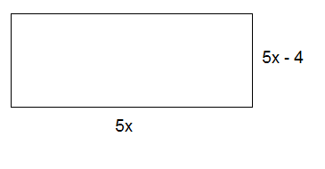

Part V for the given expression, identify the terms, like terms, coefficients, and constant terms then simplify the expression.
- $5x+3+8x$

- $-7b+4+b-10$

- $4x+3x$

- $3\left(2y+4y\right)$

